CS 340 README

About the Project/Project Title

The CRUD_Python_Module will establish Create, Read, Update , and Delete (CRUD) functionality operations to manage data in a database. This module will utilize Python as middleware for a MongoDB database containing records for an animal shelter. By providing a structured interface, it will allow for seamless data manipulation without requiring the user to access MongoDB.

Motivation

This module was created to create middleware between the MongoDB logic and the high-level user interface. In an animal shelter, it is necessary to track animal data, such as name, breed, age and status. This module will provide an efficient way to allow the user to input new entries, read and update existing entries, and delete animals who are no longer in the shelter.

Getting Started

To get started, you will need to transfer the database records to MongoDB using

mongoimport --headerline –type=csv --db aac --collection animals --drop ./aac_shelter_outcomes.csv

When that is completed, you can set up user authentication using the following command in MongoDB after transferring to the admin database. See figure 2

db.createUser(
{
user: “aacuser”,
pwd: “SNHU1234”
roles: [ { role: “readWrite”, db: “aac” } ]
}
)

This will create a new user. For the password, use whatever password you see fit, or better practice is to use passwordPrompt(). See figure 3.

The create() function was created by first checking to make sure the data existed before inserting it using the insert_one() method and assigning that to the variable insert_result. We then used acknowledged in the return True if the insert was successfully. We also introduced the exception to throw out an error if a null value was trying to be inserted.

Similar to the create() function, the read() function takes a query and uses the find() method to search the designated collection to find the query. If it finds the query, it returns the query, else it returns an empty list.
The update() function allows the user to input the query and the data they would like to update, in the from of a dictionary. This functions allows for the data to be updated without deleting other fields of the animal.

The delete() function allows the user to delete an animal entirely from the animals collections, using a query. This will allow the user to remove animals from the database that are no longer needed, such as when an animal leaves the shelter. This will help prevent wasted resources.

For the UI, we utilized Python and Dash to create a easy-to-use dashboard for filtering information. For the Grazio, they were looking for rescue dogs, so we filtered the search to dogs only. We created a table that has only the fields needed: name, animal_type, breed, age_upon_outcome_in_weeks, location_lat, location_long, and outcome_subtype. See figure 4.

These allow for the user to quickly and easily see only dogs that fit their criteria. To make this even more intuitive, we also added button widgets that filter based on the specific type of rescue dog they are looking for: water, mountain/wilderness and disaster rescue. As well as a “Reset” button to reset the filter. See figure 4.

For ease of use for data, we included a pie chart that shows the top 6 dog breeds found within the data. This allows for the user to see how many of each dog is available at a glance. See figure 5.

Installation

Python
-Installation of the latest version of Python

MongoDB
-installation of the latest version of MongoDB to access the database

Usage

Code Example
We used MongoDB for this program because it excels in this type of data storage. As a non-relational database, we are able to store different sizes and types of data within the database without it affecting queries. This allows for the data to be obtainable. We utilized Python for the middleware and for the dashboard because of its ease-of-use and maintenance. Python is an easy language to maintain and is very readable. Python also has access to the Dash framework which allows for us to create the UI graphics, and widgets easily for the view and controller.

In the creation of this program, we utilized the following resources:

Implementation of Images in Dash
https://dash.plotly.com/dash-html-components/img

Implementation of Pie Charts in Dash
https://plotly.com/python/pie-charts/

Implementation of Charts in Dash
https://dash.plotly.com/datatable

Core Components of Dash
https://dash.plotly.com/dash-core-components

Dash Leaflet
https://dash-leaflet-docs.onrender.com/

Authenticating a user in MongoDB
https://www.mongodb.com/docs/manual/tutorial/create-users/

Implementation of the html layout and flexbox
https://developer.mozilla.org/en-US/docs/Web/CSS/Guides/Flexible_box_layout/Basic_concepts

Pandas Dataframe Documentation
https://pandas.pydata.org/docs/reference/api/pandas.DataFrame.loc.html

Southern New Hampshire University Course Materials

Tests
The tests we used are unit tests for the CRUD functions. We created a “test_animal” that contains a number of fields. We then tested the create() function to see if it added the animal correctly. Then we tested the read() function to find and display the animal’s information. We then used the update() function to update the animals age before we used the delete() function to remove it from the database again. See figure 1.

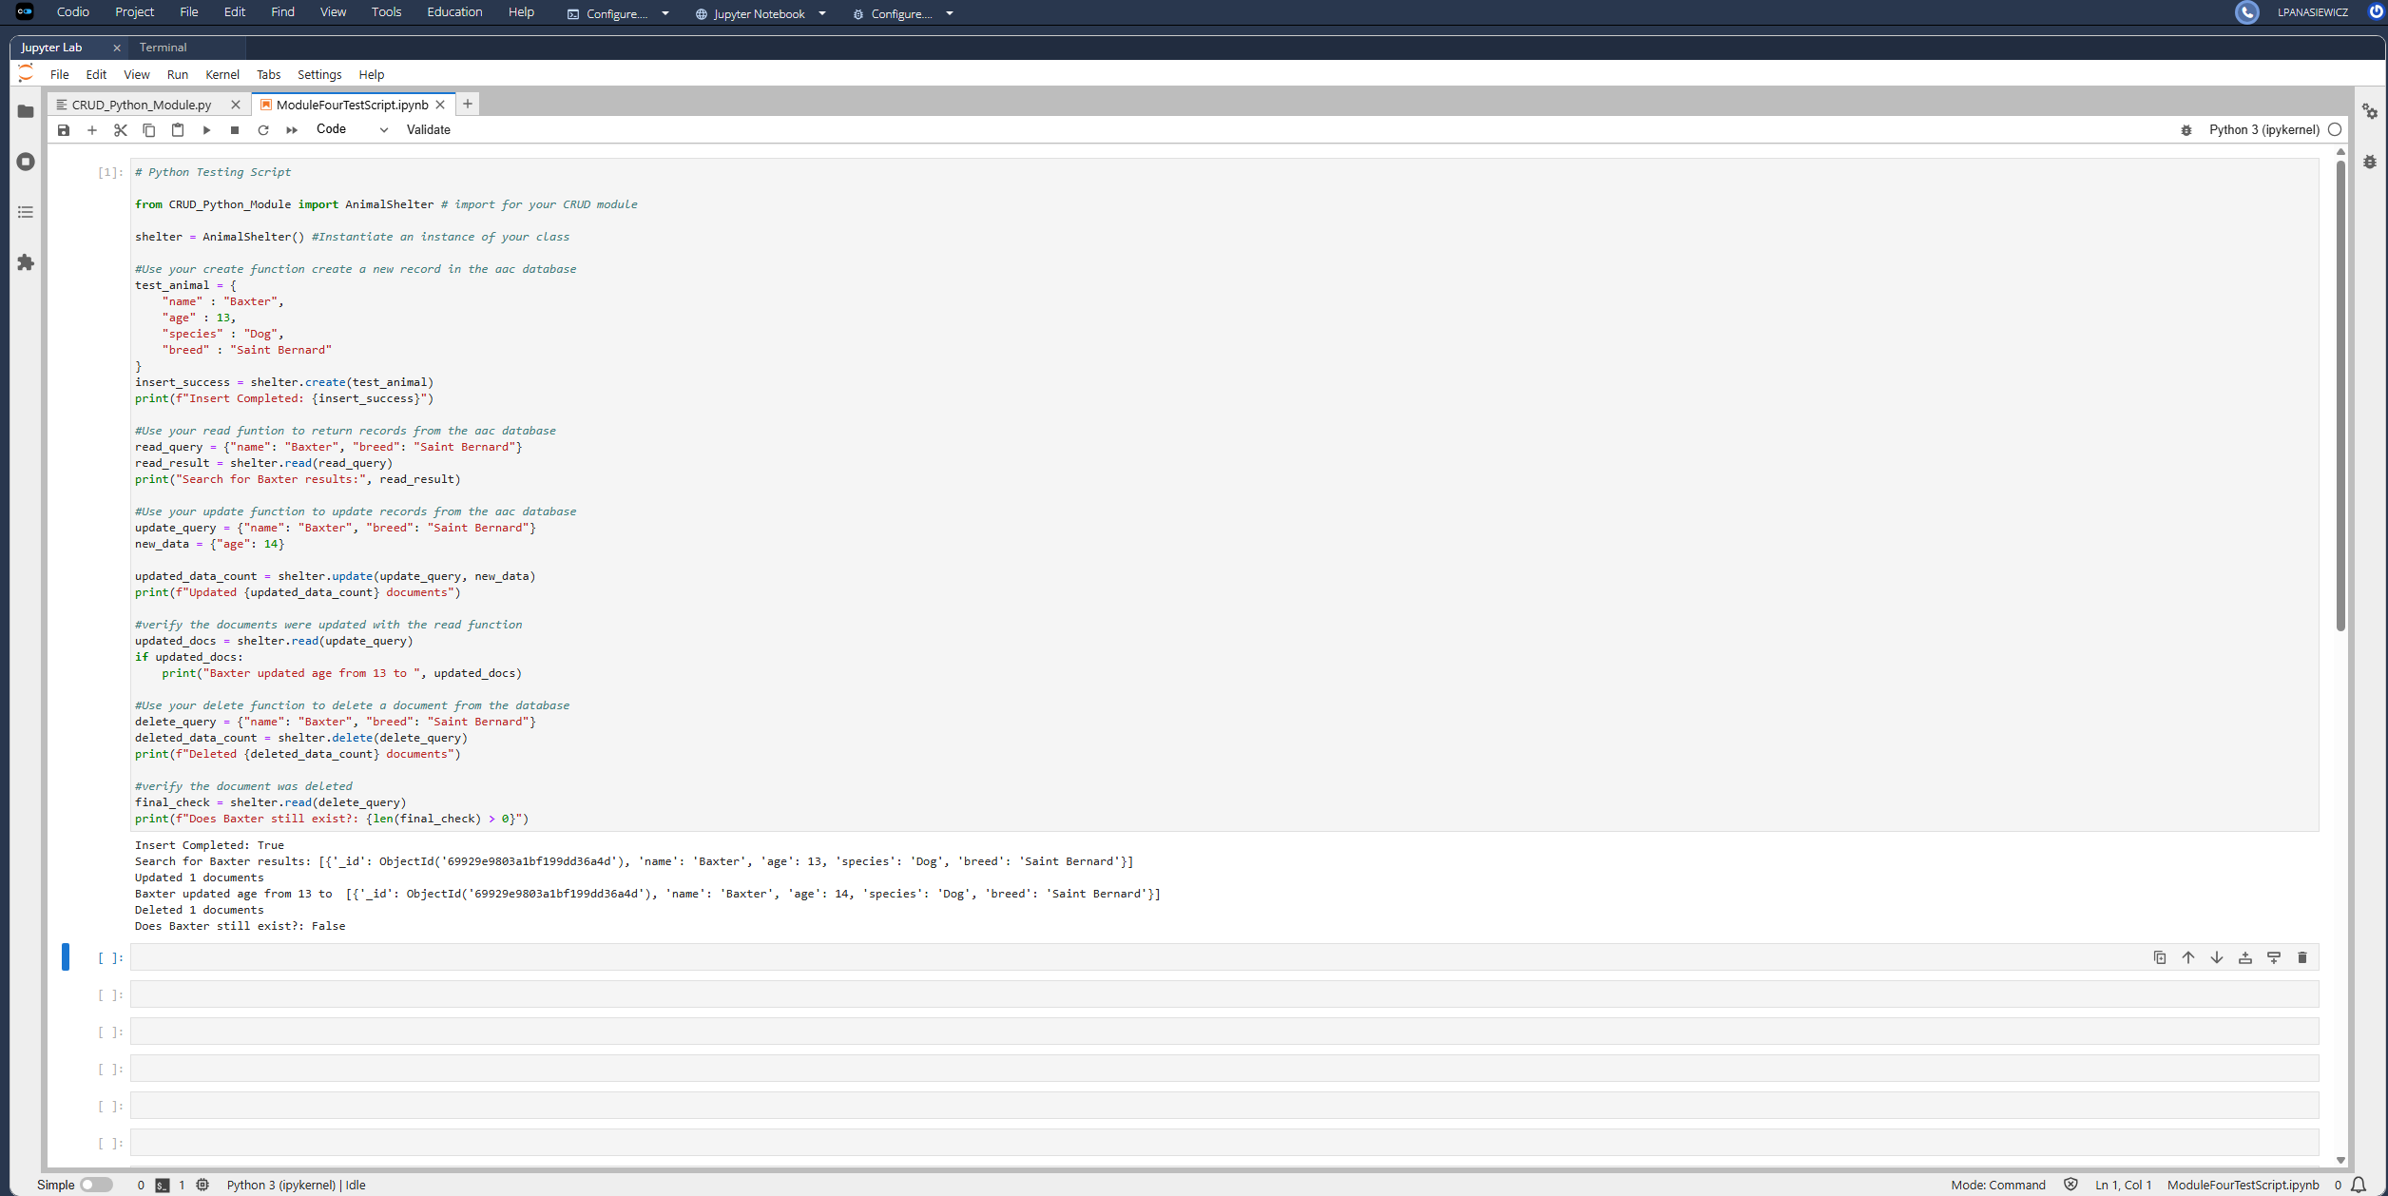

Figure 1: Screenshot to show the unit test

Screenshots
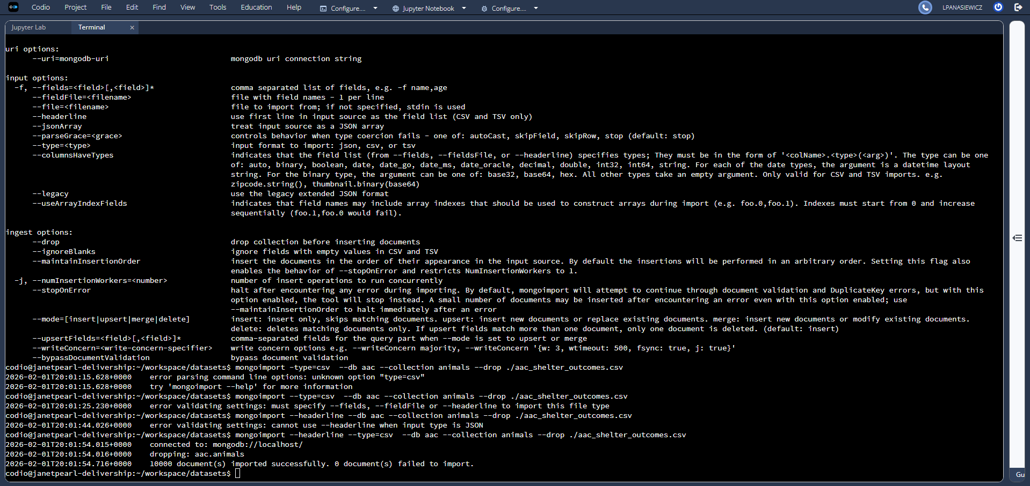

Figure 2: Screenshot to show the importation of the mongoimport tool and execution
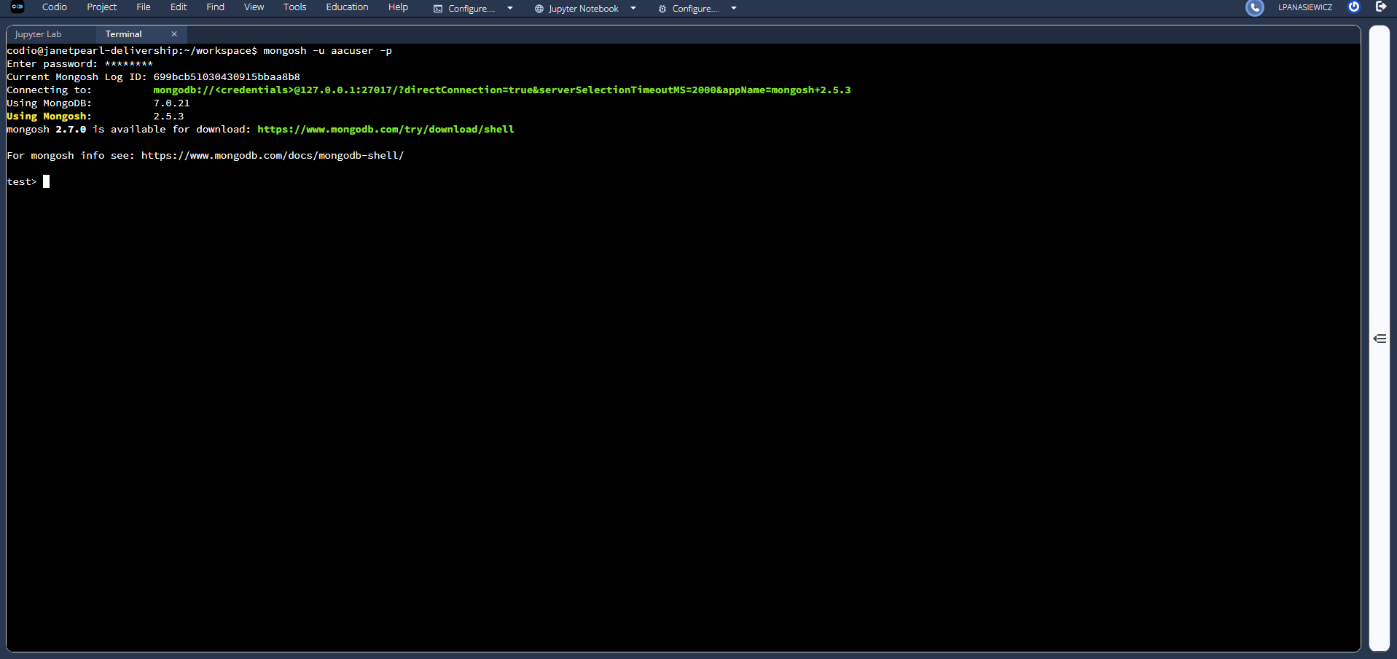
Figure 3: Screenshot to verify we are using the new “aacuser” user
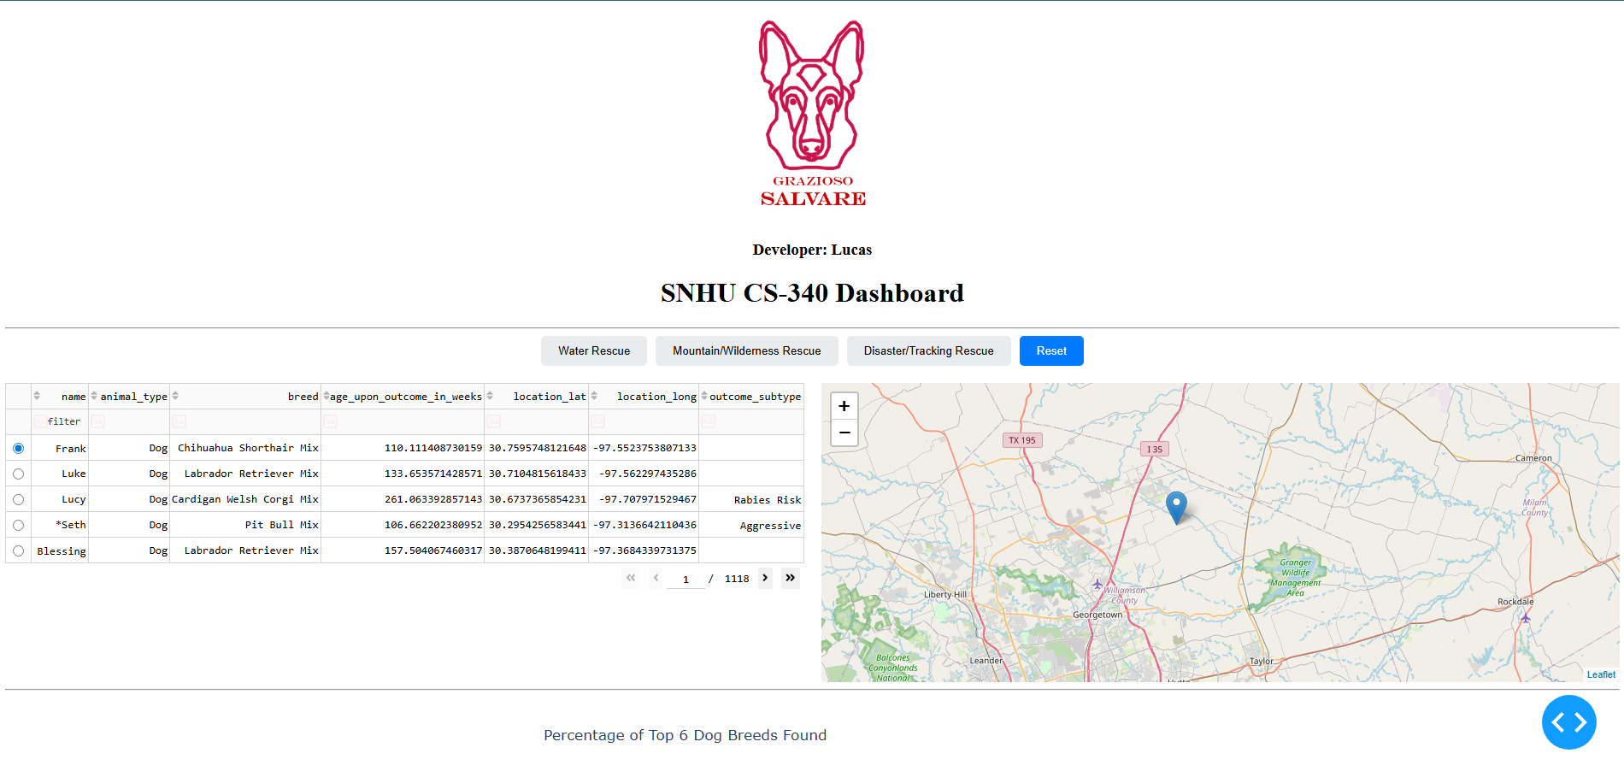
Figure 4: Screenshot to show the dashboard with updated map and working filter widgets
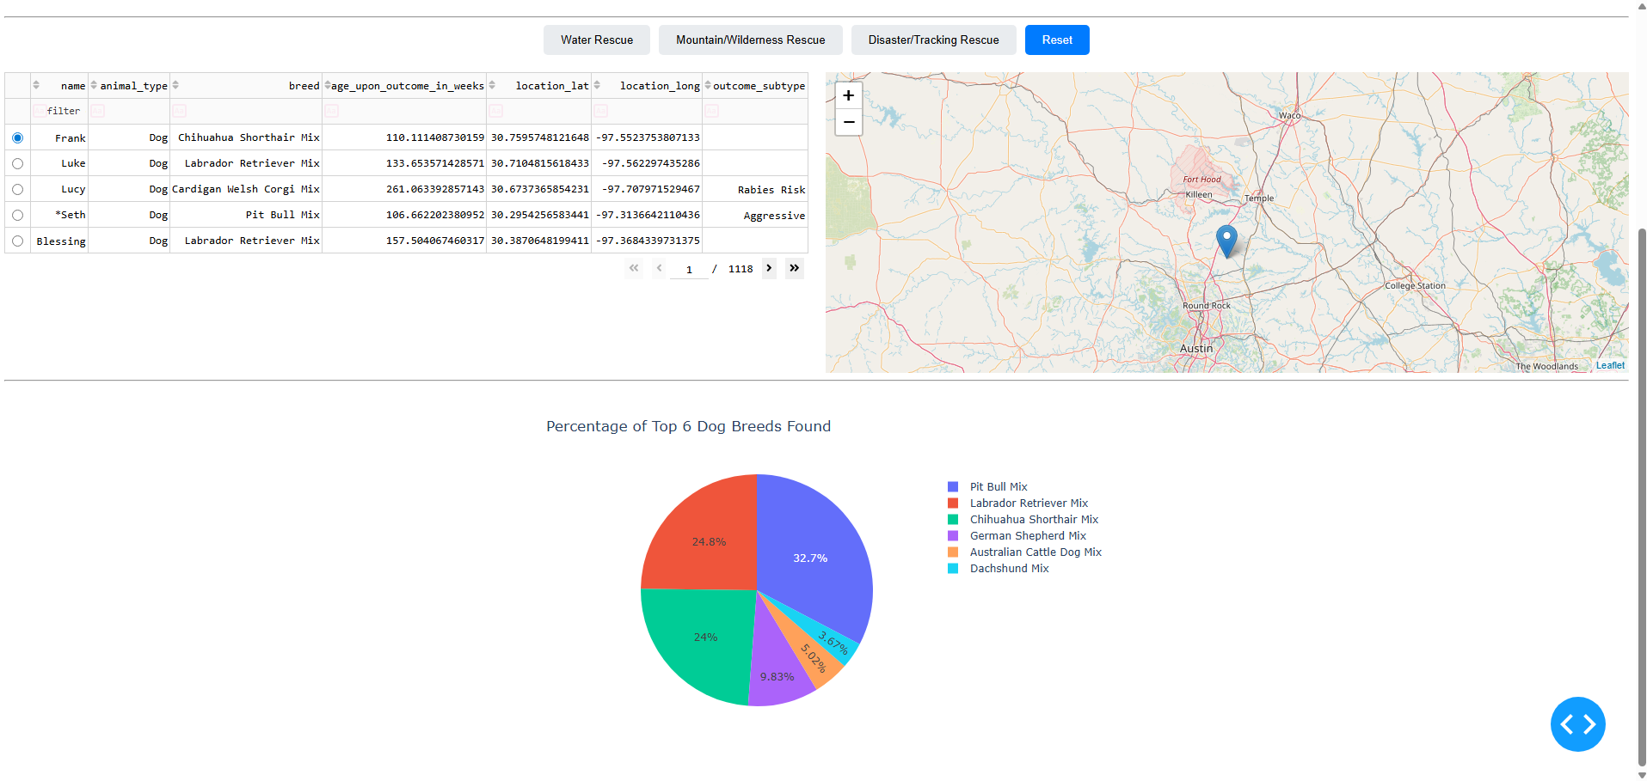
Figure 5: Screenshot to show updated pie chart displaying top 6 dog breeds with current filter

Challenges

In this program, we encounter a lot of challenges. This was our first time interacting with MongoDB and with very limited practice utilizing the Linux shell. One of the challenges that we faced was after we created the user “aacuser” we needed to set the security authentication to enabled, but there did not seem to be any obvious way to do that. It took some research and relying on past Linux drills to find the /etc/mongod.config file to write the new authentication (the screenshot was updated for this README). We also have not touched Python since the first year of our Academic degree and it took some time to relearn how the functions and methods are written compared to C++ and Java. Luckily, Python is easy to relearn. Besides for that, everything within this project was new and learning the massive amount of information was hard. Due to these challenges, this project was very rewarding.

Contact
Your name: Lucas Panasiewicz

